

Qty | Description | Price
50 | Fly mesh office chairs Height adjustable arms, seat slide, adjustable lumbar support, seat tension adjustment and Adjustable back rake. Discontinued chair!!  We have 50 of these fantastic office chairs  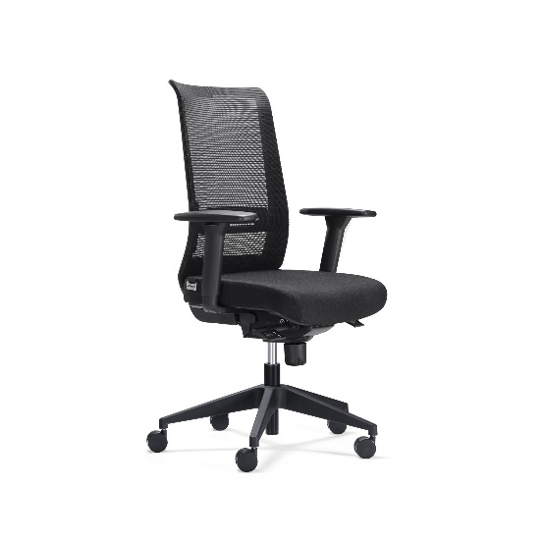 | €299.00 each plus vat  MOQ10
4 | Bisley Tambour door storage units in white with 4 shelves per unit  1.97m High x 1m wide and 470mm deep. In stock Special offer!!  RRP €565.00 each plus vat Special offer €500.00 each pus vat  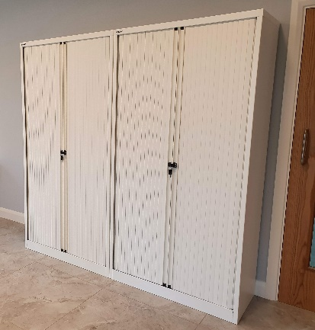 | €500.00 each plus vat
40 | 20 Green mesh office chairs and 20 red mesh office chairs. Adjustable back, height adjustable seat and height adjustable arms. End of line!!!  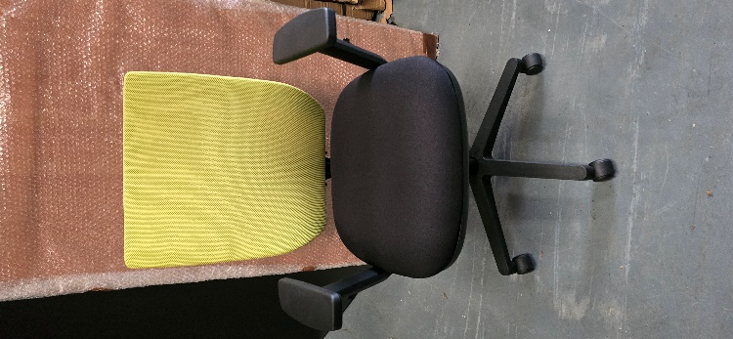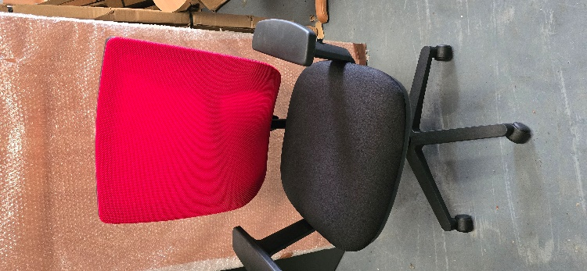 | €139.00 each plus vat
4 | Desk and pedestal bundle 1600 x 800 beech desk with 2 or 3 drawer mobile pedestal  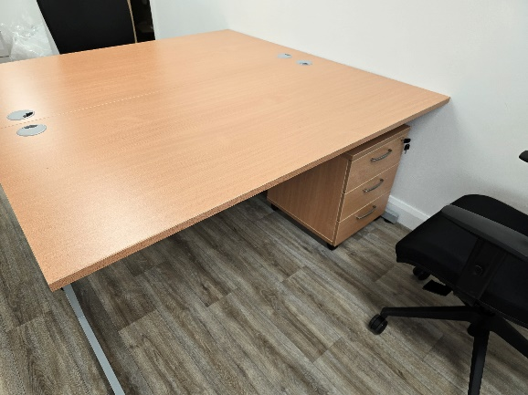 | €480.00 plus vat
2 LH and 2 RH | Radial desk and pedestal bundle 1600 mm x 1600mm in beech Available in left and right hand  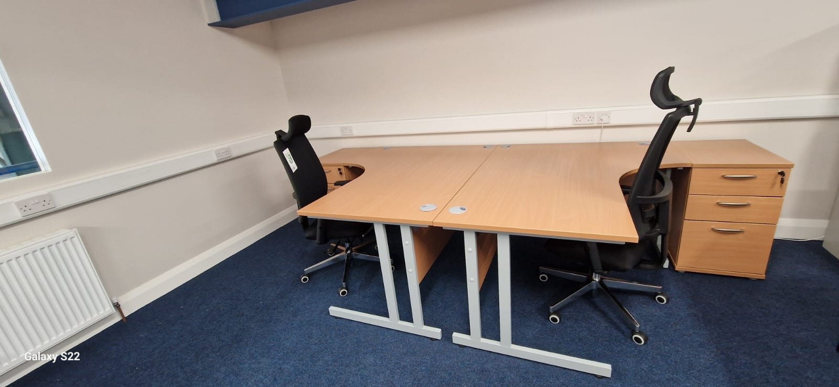 | €545.00 plus vat
1 | Nero 4m x 1.2m meeting table band new with 12 Ramunas mesh back meeting chairs with black cantilever frame  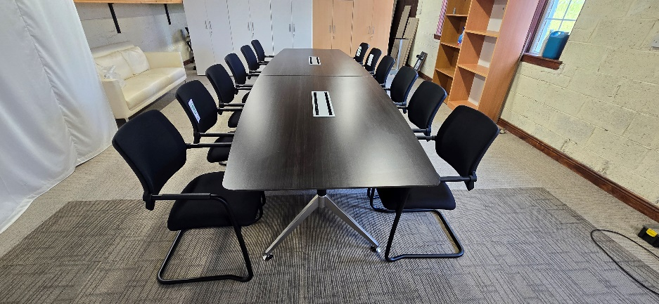 | €3699.00 plus vat
2 | Nero 4m x 1.2m meeting table brand new with 12 BC high back leather meeting chairs with chrome cantilever frame  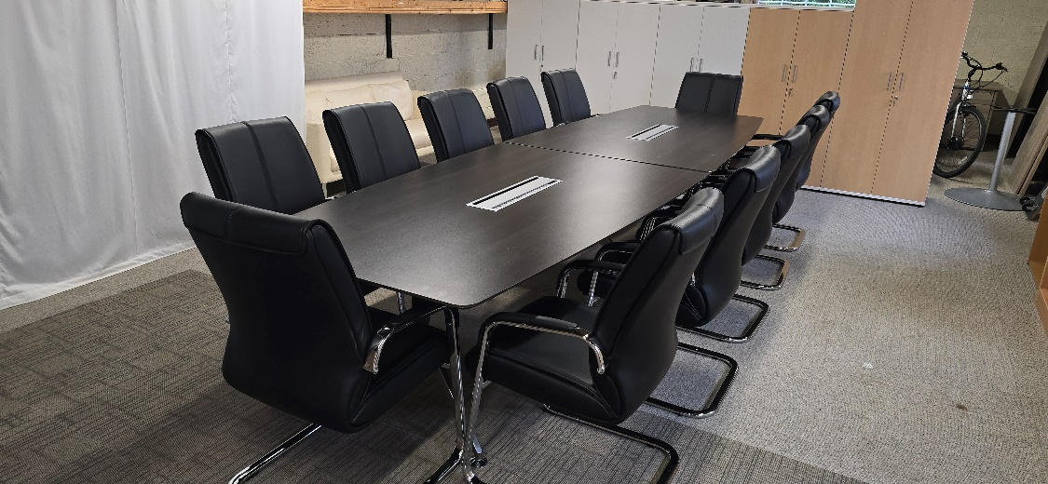 | €3250.00 plus vat
All items in stock and ready for collection or delivery
Vat @ 23%
Delivery and installation charges may apply.
Contact Simon O’Dea for more details 0864083012

